AATC_DB
Introduction
The AATC_DB module it used to access the database via frequently used commands in order to simplify the usage of the database. The database must be stored on a MySQL server rather than a sqlite3 database due to the ability of the server to use per record locking while sqlite locks each table completely if a write is taking place which would cause all other requests on that table to block, causing other user’s requests to fail.

Tables
The database uses a number of tables, the name is mostly enough to explain it’s purpose:
User → Used to store details about a user such as username, UserID, password etc.
Monitor → Used to store details about Monitors such as MonitorName, password etc.
Drone → Stores details such as DroneName, DroneID and speed.
MonitorPermissions → Used to store details such as MonitorID, UserID and expiry date.
Flight → Used to store details about flights such as start and end coordinates and start time.
FlightWaypoints → Used to store details such as WaypointNumber, coordinate, ETA.
NoFlyZone → Used to store details such as StartCoord, EndCoord and level.
DroneCredentials → Used to store the credentials for drones, seperate to prevent password being revealed if the drone information is made public.

InputStack → This is used to keep track of the inputs sent to the HedaBot program for each user, contains the inputs, current stack position and the chat_id.
Sessions → Keeps track on which chat_ids have logged into which UserIDs, allows persistent sessions for the Hedabot program.

DDL
For explanations of the purposes of the tables see the Tables section above.
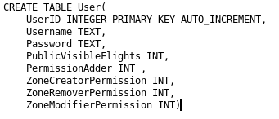
The User table uses the UserID field as the primary key, an autoincrementing integer value which uniquiely identifies the User. The Username must also be unique as the username is used to log in, however it is not the primary key as the use of an intermediary allows the future feature of changing the username after creation while retaining the User’s drones and permissions.
The password contains the salted hash of the password of the user.
The PublicVisibleFlights value contains an integer value (0,1) to show if the flights should be publicly shown. Not a boolean value as the integer value would allow later alteration to have multiple levels of visibility.
The PermissionAdder integer value controls if the user may alter their own permissions, as above the integer value allows segmentation of permission adder levels.
The Permission fields control if the user has permission to perform the task, again integer values allow later modification into seperate levels of permissions.

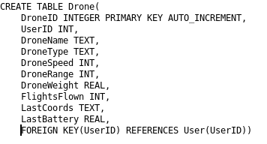
The Drone table has the primary key of DroneID. The pair (UserID,DroneName) must be unique , however as with the user table this combination is not the primary key as the drone name could gain the future feature of being changed after creation. The Drone* value contain attributes about the drone such as speed , range and weight with the types being appropriate to the attribute. FlightsFlown keeps track of the number of flights the drone has completed. LastCoords and LastBattery keeps track of the latest status of the drone sent to the server , LastCoords being in “(x,y,z)” form. The UserID foreign key links to the userID of the User table.

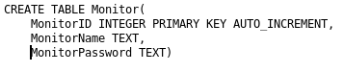
The monitor table has the primary key MonitorID, an auto incrementing integer. The name of the monitor is also unique but not the primary key in order to allow the future ( not implemented in this NEA) feature of changing the name of the monitor after creation. The MonitorPassword contains the hash of the password of the monitor.

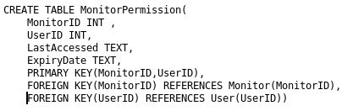
The MonitorPermission table has the composite primary key MonitorID and UserID. This links the tables and the existance of such a link indicates to the program that the monitor has permission from the user to access the drones, flights and flight waypoints of the user. The LastAccessed entry could be used to indicate each time the monitor uses the permission, however it will most likely not be used due to the performance penalty of updating the table each time a record is accessed. The ExpiryDate contains the text date of when the permission will expire. Note: ExpiryDate and LastAccessed are both Text values as this will allow both the use of Unix Epoch time as well as human readable date in the YYYY:MM:DD:HH:mm:SS format if desired. Finally the program places the contstaints that the MonitorID and UserID must reference UserIDs and MonitorIDs in their respective tables.

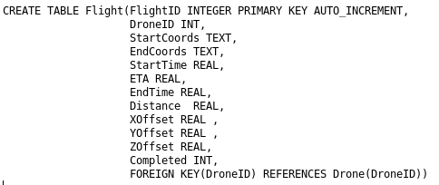
The flight table has the primary key FlightID, an autoincrementing integer. The DroneID field is a foreign key for the drone which for which the flight is for. The StartCoords and EndCoords values contain the string representation of the coordinates where the flight begins and ends. The StartTime contains the time at which the drone should start, a real number instead of a Text date as with MonitorPermission as this will almost certainly only be used by the drones. The ETA is the programs estimation of arrival time. The End Time contains the ETA until the flight is complete, after which it contains the true EndTime of the flight, the discrepancy between ETA and EndTime can be used to improve the accuracy of the ETA prediction. The Distance field contains the distance of the flight. X,Y,Z offset contains the random offset in each dimension the flight will use to reduce the chance of paths crossing. The Completed field contains the integer completion code ( 0 , not finished, 1 finished , more can be added).

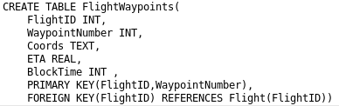
The FlightWaypoints table has the composite primary key FlightID , which references the FlightID of a flight using the Foreign key constaint ,and the WaypointNumber , the number waypoint this entry represents. The Coordinate field contains the coordinate of the waypoint in text form. The ETA is the estimated arrival time of the drone at the waypoint. BlockTime could be used as a signal for the drone to wait at this location for a given amount of time, however this feature is not part of the project.

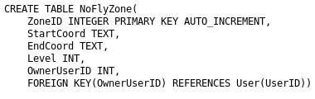
The NoFlyZone table has the primary key ZoneID , an autoincrementing integer. The Start and End Coord fields contain the text representation of the volume the NoFlyZone spans. The Level field represents the integer level of the NoFlyZone, 1 → No different to normal , 100 → Avoid 100x more than normal. The OwnerUserID is the foreign key of the UserID in the UserID, identifying the creator of the NoFlyZone.

The DroneCredentials table has the primary key DroneID linking the Drone and DroneCredentials tables. This stores the credentials of the drones seperatly to prevent disclosure if the drones are made publicly viewable ( drone passwords are stored in plaintext so the user may retrieve them).

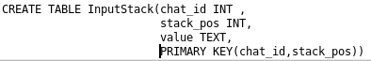
The InputStack table has the composite primary key of ChatID and StackPos. The combination links to the value text entry stored in the table.

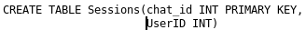
The sessions table has the integer primary key chat_id which is the chatID of the telegram chat. This links to the UserID, indicating that this chatID has the current UserID UserID.

Notes

Note:The database does not use marked foreign keys as this causes errors to be raised if contraints are not fulfilled even if the contraints would be fulfiled shortly after. An example of this would be in the Sessions table, where a chat_id and UserID mark the user the chat is logged in as , per default if a user is not logged in they are given the value -1. This would be a foreign key for the UserID in table User, however as the UserID -1 is reserved for users who are not logged in this would raise an error. Therefore foreign keys are not explicitly defined even though they are present logically.
Note2: Most forigen keys now have been implemented, however the chat_id forigen key cannot be implemented in Input_Stack as this depends on an entry in Sessions which is only added on first login once the Input_Stack has already been used.

The methods used follow a general structure. The command takes 0 or more parameters, executes the relevant commands including checks if the inputs are valid if necessary and returns Sucess, Message and optionally Data. Sucess is boolean, Message String and list Data. The SQL commands use placeholders “%s” in order to reduce the chances of SQL injection occuring.

Import
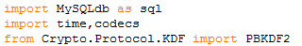
The program requires a number of modules, MySQLdb for a connection to the database, time in order to obtain the current time, codecs to convert to and from byte strings and PBKDF2 for hashing of passwords.

Misc functions
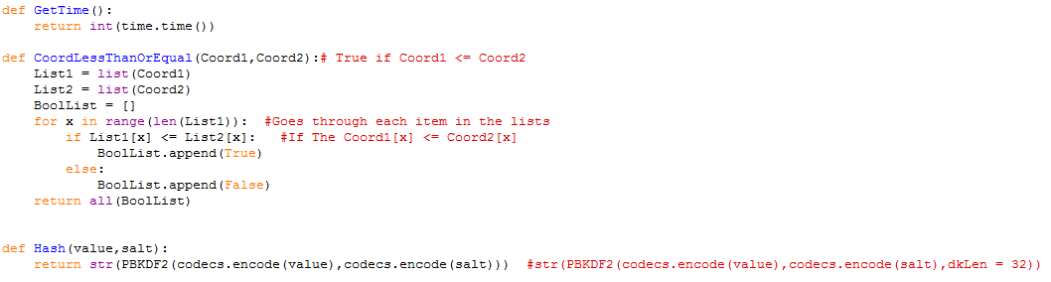
The GetTime function is used to easily obtain an integer time value without requiring a large number of function calls , making the program simpler.

The CoordLessThanOrEqual is used to check that the coordinate points are valid for a NoFlyZone. All Coordinate pairs of NoFlyZones (Coordinates defining the cuboid volume marked as a NoFlyZone) must be in the form CoordinateA <= CoordinateB for all dimensions. The normal comparator function would not work as if XA < XB then Y and Z will not be considered as shown below where A and B define Coordinates A and B.
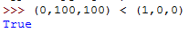
Therefore the function converts the coordinates into lists and compares the coordinates in each dimension, storing the result in a list. If not all of the values in the list are True ( At least one dimension exists where DA > DB where D = dimension and A and B define Coordinates A and B) then the all function will return false, indicating that the coordinates are invalid. Otherwise the program will return True.

The Hash function is used to cryptographically hash passwords in order to prevent the passwords being compromised should the database be compromised. The PBKDF2 function hashes the password (value) and salt repeatedly in order to increase the time required to calculate the hash, reducing the number of keys a program such as OCLhashcat could search through in order to discover the keys. In order to reduce the effectiveness of rainbow tables ( precomputed hash tables) the username is used as a salt for the hashing function. The function returns the computed hash.
Note: User and Monitor passwords are hashed while DroneCredentials are not. The DroneCredentials are not hashed as otherwise the GetDroneCredentials function would not be functional (would only return the irreversible hash) and it is likely that the drone credentials would have to be looked up repeatedly. The frequent lookup would be necessitated by a large number of drones being stored resulting in many different passwords, therefore requiring a way to store these passwords in most cases, the storage on the server being a convenient solution.

DBConnection

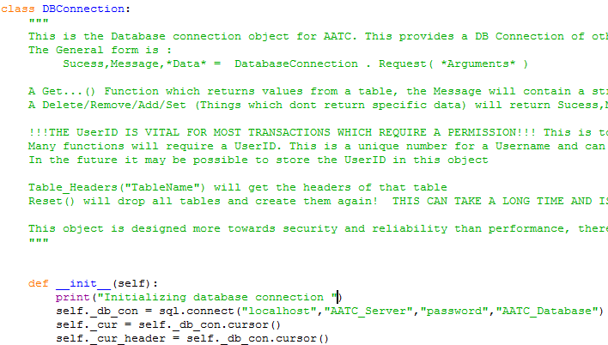
Misc Methods
This class is used as an interface to the database. The connection to the database is formed using sql.connect with the location localhost (MySQL server on the same computer, this can be changed if necessary), username AATC_Server , password password and target database AATC_Database. This connection object is then stored in the db_con attribute and two cursor objects are derived from this connection. A cursor object is used to execute SQL commands and to fetch the results. The first cursor is used as a general cursor in order to run commands for the database, the second is used to obtain the column names for the tables when necessary so that the columns can be accessed by name by the client programs.
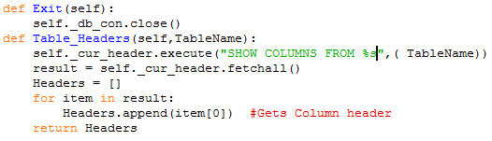
The exit method is used to close the connection to the database.

The Table Headers method is used to obtain the headings for a given table. A client may need to identify the location of a specific column in order to further use the information stored in the column, if this location were hard coded then errors would occur if the columns where rearranged. The knowledge of the column headings would allow indexing of the correct column (column names are very unlikely to change as that would alter many SQL requests). Furthermore in cases such as if a User requests details for a given table then the inclusion of the column names makes it easier for a user to read this data (i.e. using the headings to label the table displayed to the user).
The method takes one argument TableName , a string of the table which is requested. The SQL statement to obtain the column headings is executed an the result obtained from the cursor. An empty list for the headings is created, then the program loops through each item in the result and obtains the first subitem in each item ( the string heading of the column). This list is then returned.

Server DB methods
Drone Methods
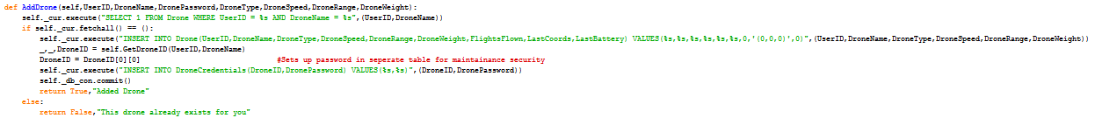
The AddDrone method is used to add a new drone to the database. The method requires the integer UserID, String Drone name, password and DroneType, integer drone speed and range and the float weight of the drone. First the program checks if the user already has a drone of that name as drone names are unique for a given UserID. If no such drone exists then the program may continue, otherwise a failure message is returned. The drone details are then inserted into the table, default values are set for flights flown, last coordinates and the last battery. The DroneID is obtained using the GetDroneID method and the DroneCredentials are setup. Finally the changes are commited and the success message returned.

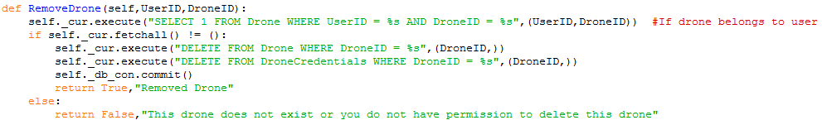
The RemoveDrone method is used to remove a drone from the database , for a given UserID and DroneID, both integer arguments. First the method checks if such a combination exists. This is used to ensure that the drone exists as well as that a different user cannot remove a drone belonging to another user by ensuring that the drone is linked to that user ( the user owns the drone). If the UserID and DroneID combination does not exist a failure message is returned. If the combination does exist the records for that DroneID are deleted , the changes committed and a success message returned.

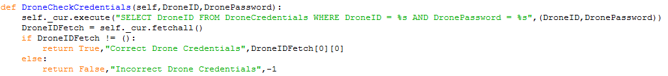
DroneCheckCredentials is used to verify if a drone logging in has the correct login details. The method takes the DroneID and DronePassword of the drone logging in. Then the program searches for such a record in the table, if one is found then the login must be correct and a success message is returned. If not a failure message is return. The DroneID is returned in the Data section as an integer as this will be directly processed by the server rather than being sent to the drone, the value allows the server to keep track as who the drone is signed in as.

The DroneGetDroneInfo method is used by drones in order to obtain the information about themselves. This is mostly required by the simulation, however it could be used by an actual drone to limit range etc. The method takes an integer DroneID and obtains the details for that drone and returns them.

The GetDroneID method is used to obtain a droneID for a given drone name belonging to a given user. This takes the integer parameter UserID and string DroneName , searches for the relevant DroneID and returns these details. The use of the UserID prevents other users attempting to find out the names of other user’s drones when not allowed as if the UserID is different the program will not find the record.
The GetDroneCredentials method is used to obtain the credentials belonging to a drone. The method takes two integer parameters UserID and DroneID. The SQL statement obtains all the drone credential details for that droneID , checking in the SQL statement that the UserID belongs to the owner of the drone.

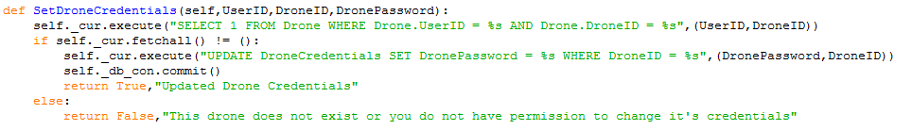
The SetDroneCredentials method is used to alter the drone credentials for a given drone, using the integer parameters UserID and DroneID and the string parameter DronePassword. The program checks that the user owns the drone. If this is not true then the program returns a failure message, otherwise the program updates the drone credentials with the new password, commits and returns a success message.

CheckDroneOwnership is used to check if a UserID owns a given DroneID. The method takes two integer parameters UserID and DroneID. The search is performed and the results returned ( 1 if True , nothing if false).

The GetDroneInfo method is used by a User in order to obtain the details about a certain Drone. The method takes two integer arguments UserID and DroneID. A search is performed for a Drone with the DroneID and where either the owner has set the visibility to public or the owner is that of UserID. The results are obtained and returned.

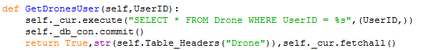
The method GetDroneUser is used to obtain all the details of all the drones belonging to the user. The method takes one integer argument UserID and selects all from the Drone table which belong to the UserID, the result is obtained and returned.

The GetDronesAll method is used to obtain the details of all publicly visible drones. This selects all drones where the owner has the publicVisibleFlights field set to 1.

The UpdateDroneStatus method is used to update the status of a drone. This ensures the key details such as the last known coordinates and battery level values are stored on the server. The method takes 3 parameters, the integer DroneID, the coordinates in string tuple form and the float LastBattery. This information is updated for the relevant DroneID. The changes are committed and the success message returned.

User Methods
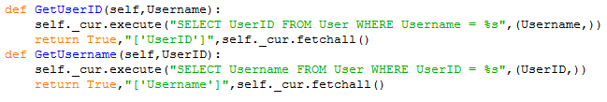
The GetUserID and GetUsername functions work in a similar fashion, obtain the relevant detail using the other known piece of information for the Username-UserID pair ( each Username and each UserID is unique and links to a single of the other type). The methods return the relevant values.

The AddUser method is used to add a new user. The method takes an Username and a Password , both in string form, a check is run that this Username does not already , if so a failure message is returned, otherwise the user is added with the default values set and a success message is returned.

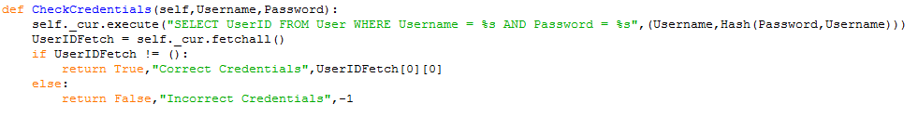
The CheckCredentials method is used to check if a user logging in has the correct credentials. This takes the Username and password and searches for an occurance in the database which these credentials, if one is found a success message is returned with the relevant UserID, otherwise a failure messages is returned and a UserID of -1.

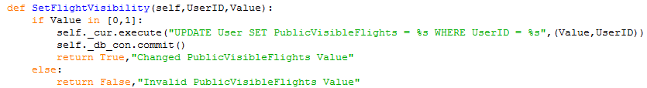
The SetFlightVisibility function is used to set the flight visibility of a Users Drone, flights and flight waypoints. If set to 1 these details will be visible to anyone, if set to 0 only the user may see these details as well as any monitors which have been given permission. The method takes two parameters, UserID and Value, both integers. The Value is checked that it is either 1 or 0 as only these values are allowed and the table updated if the value is ok and a success message returned, otherwise a failure message is returned.

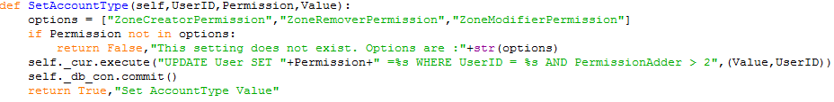
SetAccountType is used to set the account type of the current account, allowing the alteration of permission values. The method takes an integer UserID, a string permission and an integer Value. First the Permission is checked that it belongs to an allowed field, if not then a failure message is returned. Then the database is updated for that permission for that UserID if the PermissionAdder value is greater than 2 ( default 0 – to prevent users altering their permissions when not allowed to). The use of string concantation is safe here as the Permission value must be in the options list and all other values are passed through via replacement , preventing SQL injection. The changes are committed and a success value returned.

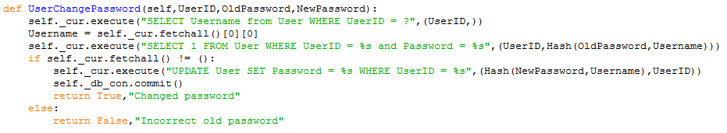
The UserChangePassword method is used to change the password of a User. This requires the UserID, OldPassword and NewPassword. First the Username belonging to the UserID is obtained, this will exist as the User has been able to login. This Username is used as the salt for the password hash. Then the program checks the old password is correct, if it is then the password is updated and a success message sent, otherwise the failure message is returned.

Flight methods
The GetFlightsUser method is used to obtain all flights belonging to the user, with that integer UserID. This obtains all the flights which are for a drone belonging to that user. The results are returned.

The GetFlightsAll method is used to get all public flights, selecting all flights which are owned by a user which has the PublicVisibleFlights set to 1. The collected results are returned.

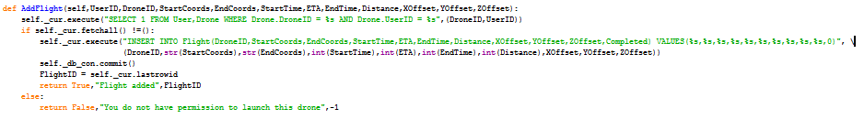
The AddFlight method is used to add a flight to the database. The method requires the UserID, DroneID, string start and end coords, float/ int start time, eta , end time and distance and the float offsets for each dimension.
The program first checks that the User owns the Drone being added to the flight. If the user does not own the drone a failure message is returned, if not the flight is added and the details returned along with the flightID.

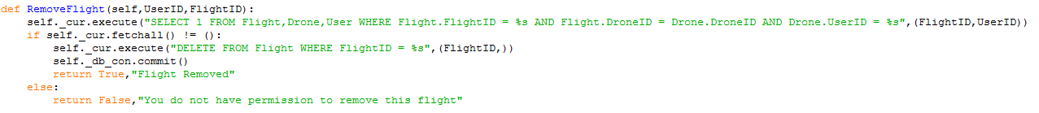
The RemoveFlight method is used to remove a flight. The method takes the UserID and FlightID and checks that the User owns the flight. If not then a failure message is returned, otherwise the flight is removed and a success message returned.

The Check for flight method is used to check for a new flight for a drone. This takes the DroneID and the MaxLookAheadTime ( maximum start time in the future the program will accept a flight as available). InvalidateDelay is used as a marker to prevent old flight from being started ( 1800 means 30 min late, can be changed as 1800 seconds was meant for testing purposes only). The program searches for a flight starting between these times which has not been completed and selects the earliest starting one if such a flight exists. If such a flight exists a success message is returned along with the flightID , otherwise a failure message is returned.

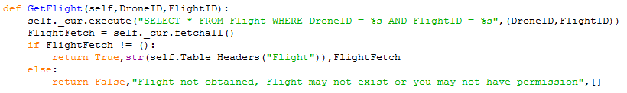
The GetFlight method is used to obtain the details of a flight for a drone. This takes the integer DroneID and FlightID arguments. First it is checked that the drone is linked to this flight, if not permission is denied, otherwise the details are returned.

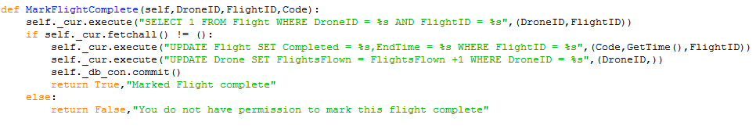
The MarkFlightComplete method is used to mark a flight completed, taking the DroneID, FlightID and code with which to mark the flight. First the program checks that the drone has permission to alter the flight, if not an error message is returned. Otherwise the program updates the flight record with the code and real end time. Additionally the number of flights flown by the drone is increased by 1. The changes are committed and success returned.

The GetCompletedFlightIDs method is used to obtain all the flightIDs for flights which are completed. This is used by the cleaner process to identify those flights which are completed and are older than EndTimeThreshold or are three times further back in time than EndTimeThreshold. This is used to remove those which are completed first and later those which were not started. The details are returned.

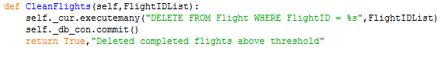
The CleanFlights method is used to remove all flightIDs in the FlightIDList argument. The program removes all of these flights i.e. if the cleaner needs to remove these old flights. All of the flights in the list are deleted and a success message returned.

FlightWaypoint methods
The GetFlightWaypoints is used to obtain the waypoints for a specific flight. The method takes the integer arguments DroneID and FlightID. The program obtains all the waypoints linked to the flight which has that DroneID and FlightID and returns them.

The GetFlightWaypointsUser method is used to obtain all the flight waypoints belonging to a given UserID argument. This selects all the flight waypoints which link to a flight which links to a drone which is owned by the user. The obtained results are returned.

The GetFlightWaypointsAll method is used to obtain all the flight waypoints which are publicly avaliable. This selects all waypoints which link to flights which link to drones which link to users who have made their flights publicly visible.

The AddWaypoint method is used to add a waypoint to the database. This takes the UserID, FlightID, waypoint number, coordinates, ETA and optionally block time. First a check is undertaken to ensure the user owns this flight and so can add waypoints, if not a failure message is returned, if the do own the flight then the waypoint is added and a success message is returned. Note: This method is no longer used due to being rather slow and having noticable overhead by checking ownership each time it is called.

The AddWaypoints method is used to add the waypoints in batches. This improves performance by only checking ownership once and only committing changes once. The same check system is run as with the AddWaypoint method , if successful the program runs executemany instead , adding all the waypoints in a single batch.

The RemoveFlightWaypoints method is used to remove all the flight waypoints for a single flight i.e. if a user deletes a flight. The check is run to confirm ownership of the flight , then all waypoints are removed which have that flightID.

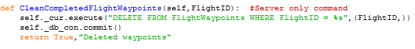
The CleanCompletedFlightWaypoints method is used by the cleaner process to remove flights without requiring the UserID of the flight , this deletes all waypoints which have the flightID passed to the method. This is for internal use only as it allows the entity running the command to delete waypoints at will i.e. any user could delete any waypoints they want.

Monitor Methods
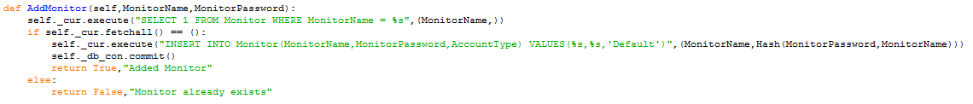
The AddMonitor method is used to add a new monitor. First a check is run to ensure a monitor with this MonitorName has not yet been created. If one has a failure message is returned, othewise the new monitor is added with the default account settings and a success message is returned.

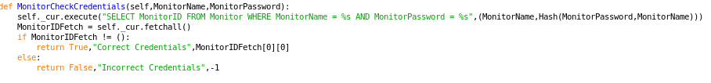
The MonitorCheckCredentials method is used to check the credentials of a Monitor logging in on the server. The method takes the MonitorName and MonitorPassword string parameters, selects the relevant MonitorID if the record exists and returns the result if such a record exists or -1 if it does not, along with the relevant event message.

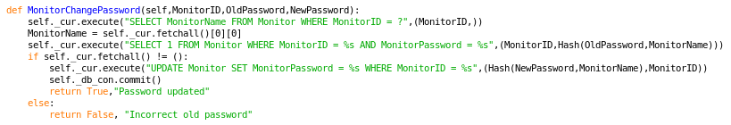
The MonitorChangePassword method is used to change the password of a Monitor. This requires the MonitorID as well as the new and old passwords. First the program obtains the MonitorName required for the hashing function, then the program checks that the old password is correct, if not the program returns a failure message, if it is correct then the record is update with the new password hash and a success message is returned.

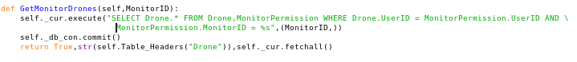
The GetMonitorDrones method is used to obtain all the drone to which the Monitor has access via a monitor permission. This requires the integer monitorID in order to obtain all the drones which are linked to the monitor via a monitor permission between the monitor and the owner of the drone. The results are returned to the caller.

The GetMonitorFlights method is used to obtain all the flights to which the monitor has access. This is completed by obtaining all flights which are connected to a drone which is owned by a user which has a monitor permission with the monitorID passed into the method. The results are returned.

The GetMonitorFlightsWaypoints method is used to obtain all the flight waypoints to which the monitor has access. This is completed by obtaining all flight waypoints which link to a flight which links to a drone which links to a User who has a monitor permission with the monitorID passed into the method. The results are returned.

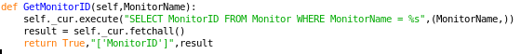
The GetMonitorID method is used to obtain the monitorID of a given MonitorName in string form. The method obtains the monitorID for the relevant MonitorName and returns the result.

The GetMonitorName method is used to obtain the monitor name of a given monitorID. This selects the MonitorName with the relevant monitorID and returns the result.

MonitorPermission methods
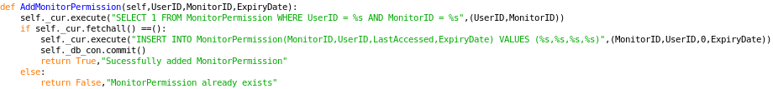
The method AddMonitorPermission is used to add a new monitor permission to the database. This takes the integer UserID, MonitorID and expiry date as arguments. A check is run to ensure the record does not already exist ( This is used instead of IF NOT EXISTS as this will return if the new record was added or not) , if it does exist the relevant message is returned, if not the record is added to the database and another relevant message is returned.

The RemoveMonitorPermission method is used to remove a monitor permission from the database, taking the UserID and monitorID for the permission which should be removed. The relevant record is deleted from the database and a relevant message returned.

The ModifyMonitorPermissionDate method is used to alter the expiry date of a monitor permission. This takes the UserID, MonitorID and new expiry date as arguments and updates the relevant record.

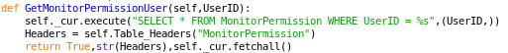
The GetMonitorPermissionUser method is used by a User to obtain all the monitor permission details for that User. This information is selected and returned to the user.

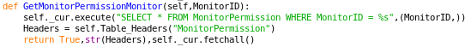
The GetMonitorPermissionMonitor method is used to obtain all the monitor permissions for a given monitor. This selects all the monitor permissions for the monitorID and returns the details to the monitor.

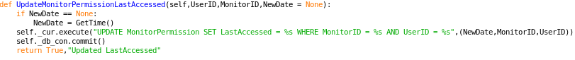
The UpdateMonitorPermissionLastAccessed method is used to update the time a monitor permission was last update ( this is not used in the project as updating each permission would require accessing each permission seperatly , increasing the number of requests needed ). If the optional NewDate argument is not used the NewDate is set to the current time. Then the LastAccessed setting is updated to the New date value for the monitor permission for MonitorID and UserID.

The CleanMonitorPermissions method is used to clean expired Monitor Permissions. The method remove permissions when called by the cleaner process per default every 10 hours, the removal of these permissions means that although during the time between the cleaner cleaning the dataabase old monitor permissions still exist and are assumed valid there are no checks needed to ensure that each monitor permission is still valid in the individual requests. This simplifies the requests for the rest of the program.

NoFlyZone methods
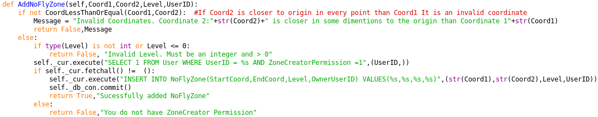
The AddNoFlyZone method is used to add a new NoFlyZone to the database. This takes the Coordinates , level and UserID. The Coordinates should be in tuple or list form. First the program checks the coordinates are in the right format using CoordLessThanOrEqual , ensuring only coordinate pairs where Coord2 >= Coord1 in every dimension are accepted. Should this not be the case an error message is returned. If this is not the case then a check is run to ensure the level value is an integer and it is greater than 0, to prevent drawing drones into a specific path when the search algorithm is run. If the check fails then a failure message is returned. Should this pass the program checks if the user has the permission to add a NoFlyZone, should this not be the case a failure message is returned. If the user does have the permission the program adds the new NoFlyZone and returns a success message.

The RemoveNoFlyZone method is used to remove NoFlyZones from the database. The program requires the ZoneID of the zone to be removed and the UserID removing the zone. First a check is run to ensure the the user either owns the NoFlyZone or has the ZoneRemover permission in order to remove the NoFlyZone. If they dont have the permission then the program returns a failure message, otherwise the program deletes the NoFlyZone and returns a success message.

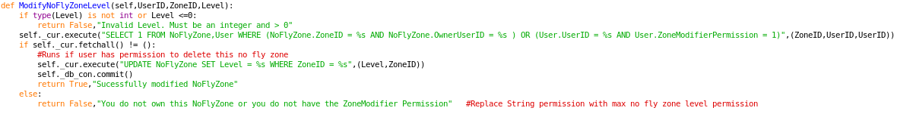
The ModifyNoFlyZoneLevel is used to alter the level of a NoFlyZone, i.e. if one wants to alter the level of the NoFlyZone due to changing conditions. First the level is checked to ensure that the level is an integer and is greater than zero. Should this not be the case then the a failure message is returned. If not the program then checks that the user either has the ZoneModifyPermission or is the owner of the NoFlyZone, in order to prevent any user being able to alter the level of a no fly zone. Should this check pass then the record is updated, if not a failure message is returned.

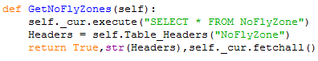
The GetNoFlyZones method is used to obtain all the NoFlyZones on the server. The NoFlyZones are obtained and returned.

Bot Commands
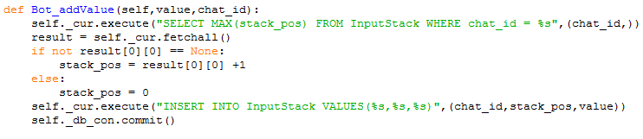
The Bot functions are used for the Hedabot module to manage the current sessions and commands. The Bot_addValue method is used to add a new value to the input stack, taking the value to add and the chat_id of the chat. First the program obtains the currently highest value on the stack, should this be a value (there is an object on the stack) then the stack value is incremented by 1, if there is not a current value then the stack position is set to 0 ( new stack). The new value is added to the input stack.

The Bot_getCommand method is used to obtain the current command on the input stack. The current command will be the bottom item on the stack ,0, this is selected and returned.

The Bot_getStack is used to obtain the entire input stack for a given chat_id. This selects all the items in the stack in ascending stack position order. The stack is then returned.

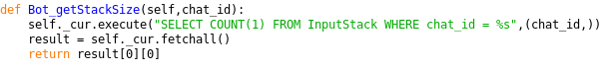
The Bot_getStackSize method is used to get the current stack size for a chat_id. This obtains the size of the stack for the current chat_id. This may be used to identify the current message needed or to check if the stack is full. The size is returned.

The Bot_flushStack command is used to empty the entire input stack i.e. if the user cancels the command. This deletes all commands on the stack for the chat_id.

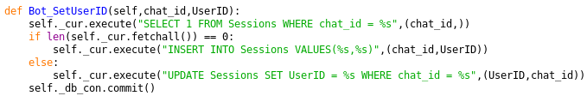
The Bot_SetUserID method is used to set the current session UserID. The program takes the chat_id and UserID to be set and checks if a record for that chat_id already exists, if the record exists it is updated, otherwise a new record is created.

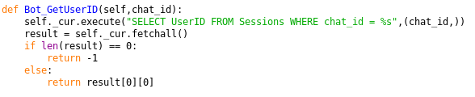
The Bot_GetUserID method is used to obtain the current UserID for a given chat. The program selects the UserID for the given chat_id. If there is no such record then the program returns -1 ( default for not logged in) , if the record exists the UserID is returned.

Reset Database
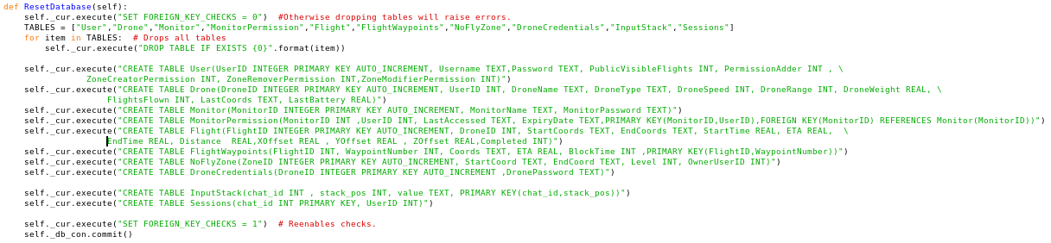
The ResetDatabase method is used to reset the entire database. This drops all tables and recreates the new tables. The old tables are dropped in a for loop after disabling forigen key checks, otherwise these would raise errors when forigen keys are used. The new databases are created and the forigen key checks are reenabled and the changes committed.

